**Image Recognition with IBM Cloud Visual Recognition**

PHASE_5

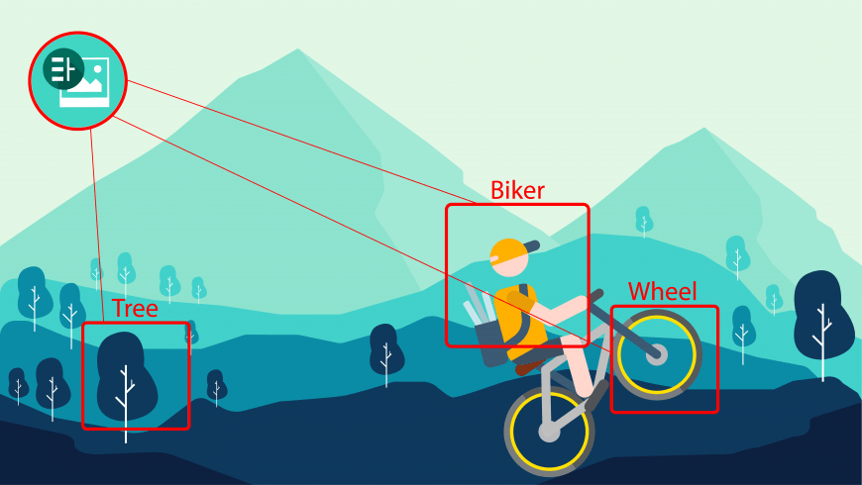

**Project Documentation & Submission**

**Documentation:**

* Outline the project's objective, design thinking process, and development phases.
* Describe the user interface, technical implementation details, and integration of IBM Cloud Visual Recognition.
* Explain how AI-generated captions enhance user engagement and storytelling.

**Submission:**

Share the GitHub repository link containing the project's code and files.

* Provide instructions on how to deploy the image recognition system using IBM Cloud and the web interface.
* Write a detailed README file explaining how to navigate the website, update content, and any dependencies.

**Abstract:**

In today's digital age, the ability to understand and interpret visual content has become increasingly critical across various industries. The "Image Recognition with IBM Cloud Visual Recognition" project explores the potential of IBM's cloud-based service to harness the power of artificial intelligence and machine learning for image analysis.

This project aims to empower developers and businesses with the capability to automatically identify objects, scenes, and concepts within images. Leveraging IBM Cloud Visual Recognition, the project encompasses both pre-trained models that offer general image recognition and custom models tailored to specific applications. The service analyzes uploaded images, assigns confidence scores to its predictions, and provides actionable insights based on recognized content.

Through this project, we explore diverse use cases, including but not limited to retail, security, healthcare, social media, and content moderation, where image recognition can revolutionize processes and enhance user experiences. The ability to create custom models allows businesses to adapt the system to their unique needs, making it an invaluable tool for a wide range of applications.

**Problem Definition:**

 The project involves creating an image recognition system using IBM Cloud Visual Recognition. The goal is to develop a platform where users can upload images, and the system accurately classifies and describes the image contents. This will enable users to craft engaging visual stories with the help of AI-generated captions, enhancing their connection with the audience through captivating visuals and compelling narratives.

**Design Thinking:**

1. **Image Recognition Setup:**

Set up the IBM Cloud Visual Recognition service and obtain the necessary API keys.

1. **User Interface:**

Design a user-friendly interface for users to upload images and view the AI-generated captions.

1. **Image Classification:**

Implement the image classification process using the IBM Cloud Visual Recognition API.

1. **AI-Generated Captions:**

Integrate natural language generation to create captions for the recognized images.

1. **User Engagement:**

Design features to allow users to explore, save, and share their AIenhanced images.

**INNOVATION DESIGN TO SOLVE THE PROBLEM:**

**1. Identify the Problem and Define Objectives:**

Start by clearly defining the problem you aim to solve with image recognition. What are the pain points or challenges you want to address? What are your objectives and desired outcomes? Understanding the problem thoroughly is the first step in designing an innovative solution.

**2. User-Centered Design:**

Put the user at the center of your design process. Understand the needs, preferences, and pain points of the end users who will interact with your image recognition system. Conduct user research and gather feedback to inform your design decisions.

**3. Iterative Prototyping:**

Adopt an iterative approach to design and development. Create prototypes or mockups of your application or system to visualize the user experience and test functionality. Continuously gather feedback from users and stakeholders to refine your design.

**4. Enhance User Interface (UI):**

Invest in an intuitive and user-friendly UI for your image recognition application. Ensure that users can easily upload images, view results, and interact with the system. Consider responsive design principles for accessibility on different devices.

**5. Improve User Experience (UX):**

Focus on optimizing the overall user experience. Streamline workflows, minimize friction, and make the process of using image recognition as seamless as possible. This might involve simplifying complex tasks and providing helpful guidance.

**6. Incorporate Machine Learning Explainability:**

Enhance transparency and trust by incorporating machine learning explainability into your system. Provide users with insights into how the image recognition model makes predictions. Explainable AI can help users understand and trust the results.

**7. Personalization and Customization:**

Explore ways to allow users to personalize and customize their image recognition experience. Provide options for users to define their own categories or tags, customize their models, or set preferences.

**8. Real-Time Feedback and Alerts:**

Implement real-time feedback mechanisms to notify users of the model's confidence level in its predictions. Alerts can help users make informed decisions based on the results.

**9. Data Security and Privacy:**

Integrate robust data security and privacy measures into your design. Ensure that user data, especially sensitive images, is protected and compliant with relevant regulations (e.g., GDPR).

**10. Collaborative Features:**

Consider adding collaboration features that allow users to work together on image recognition tasks. This can be especially useful in professional or research settings.

**11. Continuous Innovation and Updates:**

Commit to continuous improvement by regularly updating your image recognition model and software. Incorporate the latest advances in machine learning and image analysis techniques.

**12. Feedback Loops:**

Establish feedback loops with users and stakeholders to gather insights on pain points, emerging needs, and potential enhancements. User feedback can drive innovation and lead to valuable updates.

**13. Ethical Considerations:**

Keep ethical considerations at the forefront of your design and innovation process. Address potential biases in the model and ensure that your system respects user privacy and rights.

**14. Accessibility and Inclusivity:**

Ensure that your image recognition solution is accessible to users with disabilities. Follow accessibility guidelines to make your application usable by a diverse audience.

**15. Sustainability:**

Consider the environmental impact of your project. Implement sustainable practices in data storage and processing, and consider energy-efficient computing solutions.

**16. Agile Development:**

Adopt agile development practices that allow your team to respond quickly to changing requirements and incorporate user feedback.

**17. Measuring Innovation Impact:**

Define key performance indicators (KPIs) that measure the impact of your innovative features and design choices. Use data to track progress and make data-driven decisions.

**18. Iterative Testing and Feedback:**

Continuously test your innovations and gather user feedback. Be willing to iterate and refine based on the feedback received.

**1. Image Recognition Overview:**

- Image recognition, also known as computer vision, is a field of artificial intelligence that enables machines to interpret and understand the content of images and videos. IBM Cloud Visual Recognition is a cloud-based service that simplifies the process of building image recognition capabilities into applications.

**2. Setting Up IBM Cloud Visual Recognition:**

- To create an image recognition system, you need an IBM Cloud account. After creating an account, you can set up the Visual Recognition service in the IBM Cloud platform. This service allows you to analyze and classify images using machine learning models.

**3. Obtaining API Keys:**

- To access the Visual Recognition service, you need API keys that authenticate your requests. API keys are obtained when you create your Visual Recognition service instance in the IBM Cloud platform. These keys are essential for integrating the service into your application.

**4. Web Interface Design:**

- A key component of your image recognition system is the user-facing web interface. The web interface should be designed to provide users with the ability to upload images for analysis and view the AI-generated captions. Here's a breakdown of the web interface components:

**- HTML Structure:** HTML is used to define the structure of the web page, including input forms, buttons, and areas for displaying results.

**- Form for Image Upload:** You create an HTML form that includes an `<input type="file">` element, allowing users to select and upload images from their devices.

**- User Interaction:** JavaScript is used to handle user interactions. When an image is uploaded, JavaScript triggers a request to the Visual Recognition service for analysis.

- **Display of Results:** The web interface includes an area to display the AI-generated captions and may also include error messages for user feedback.

- **CSS Styling:** CSS is used to style the web page, making it visually appealing and user-friendly. You can customize fonts, colors, layout, and other visual elements.

**5.Integration with IBM Cloud Visual Recognition:**

- Within your Python code, you integrate the Visual Recognition service using the `ibm-watson` library. Key steps for integration include:

- **Authentication:** You use your API keys to create an authenticator and configure the Visual Recognition service instance with these credentials.

- **Image Classification:** The code sends the uploaded image to the Visual Recognition service for analysis. The service identifies and classifies objects in the image, providing AI-generated captions or labels.

**6. Handling Errors:**

- It's important to implement error handling within your code to provide feedback to users. For example, if the Visual Recognition service encounters issues with image analysis, it should return an error message to the web interface.

**7. Displaying Results:**

- Successful image analysis results are displayed on the web interface. The AI-generated captions or labels are shown to users, providing them with valuable insights into the content of the uploaded images.

**8. Further Enhancements:**

- To create a production-ready image recognition system, you can consider additional features such as user authentication, image storage, and more advanced user interfaces. Deployment on a web server or cloud platform is also necessary to make the system accessible online.

**OUTPUT** 👍

**Host Generation**

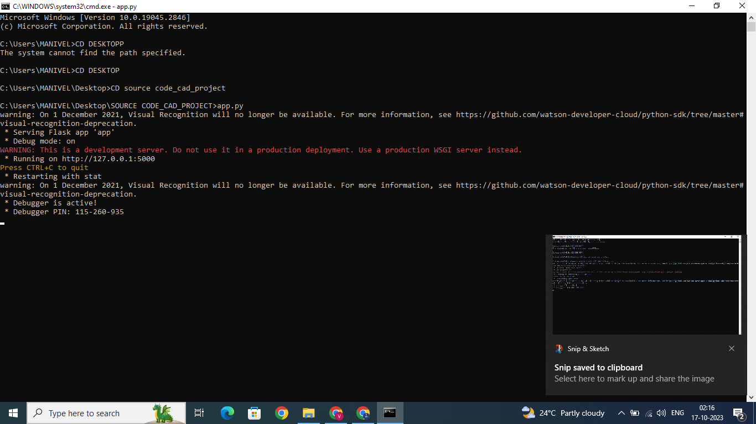

**IMAGE CAPTION GENERATOR WEB INTERFACE**

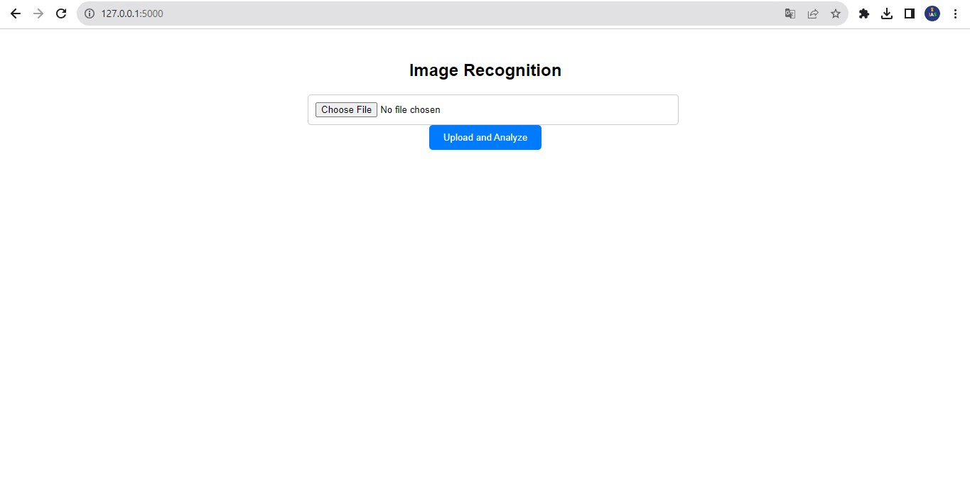

**Source code:**

**HTML Code:**

<!DOCTYPE html>

<html lang="en">

<head>

<meta charset="UTF-8">

<meta name="viewport" content="width=device-width, initial-scale=1.0">

<title>Image Recognition</title>

<style>

body {

font-family: Arial, sans-serif;

text-align: center;

}

.container {

max-width: 500px;

margin: 0 auto;

padding: 20px;

}

h1 {

font-size: 24px;

}

form {

margin-top: 20px;

}

input[type="file"] {

width: 100%;

padding: 10px;

border: 1px solid #ccc;

border-radius: 5px;

}

input[type="submit"] {

background-color: #007BFF;

color: #fff;

border: none;

padding: 10px 20px;

border-radius: 5px;

cursor: pointer;

}

p {

margin-top: 20px;

font-weight: bold;

}

.error {

color: red;

}

</style>

</head>

<body>

<div class="container">

<h1>Image Recognition</h1>

<form method="POST" enctype="multipart/form-data">

<input type="file" name="image" accept="image/*" required>

<input type="submit" value="Upload and Analyze">

</form>

{% if error %}

<p class="error">{{ error }}</p>

{% endif %}

{% if caption %}

<p>{{ caption }}</p>

{% endif %}

</div>

</body>

</html>

**FLASK Code:(app.py)**

from flask import Flask, render_template, request

from ibm_watson import VisualRecognitionV4

from ibm_watson.visual_recognition_v import FileWithMetadata

from ibm_cloud_sdk_core.authenticators import IAMAuthenticator

app = Flask(__name)

# Replace with your actual API key and service URL

api_key = "YOUR_API_KEY"

service_url = "YOUR_SERVICE_URL"

authenticator = IAMAuthenticator(api_key)

visual_recognition = VisualRecognitionV4(version="2022-08-20",

authenticator=authenticator

)

visual_recognition.set_service_url(service_url)

@app.route("/", methods=["GET", "POST"])

def index():

caption = None

if request.method == "POST":

if "image" not in request.files:

return render_template("index.html", error="No file part")

image = request.files["image"]

if image.filename == "":

return render_template("index.html", error="No selected file")

try:

# Use Visual Recognition to analyze the uploaded image

response = visual_recognition.analyze(

collection_ids=["your_collection_id"],

features=["objects"],

images_file=image

).get_result()

# Extract the top caption from the response

top_class = response["images"][0]["classifiers"][0]["classes"][0]["class"]

caption = f"AI-generated Caption: {top_class}"

except Exception as e:

return render_template("index.html", error=str(e))

return render_template("index.html", caption=caption)

if __name__ == "__main__":

app.run(debug=True)

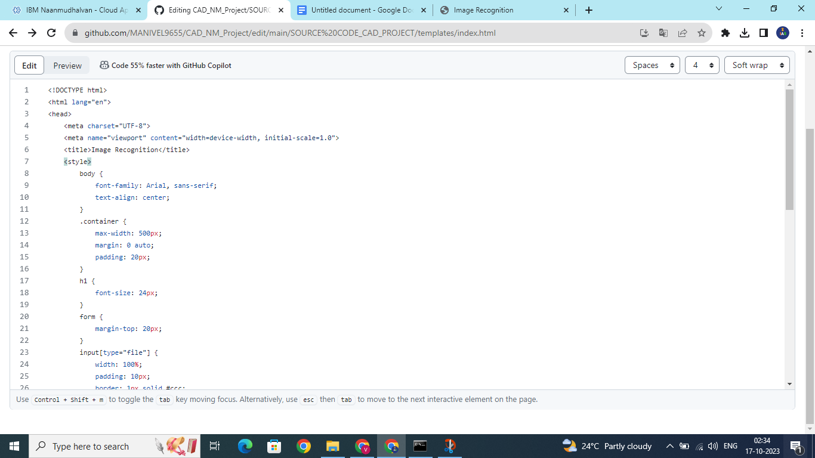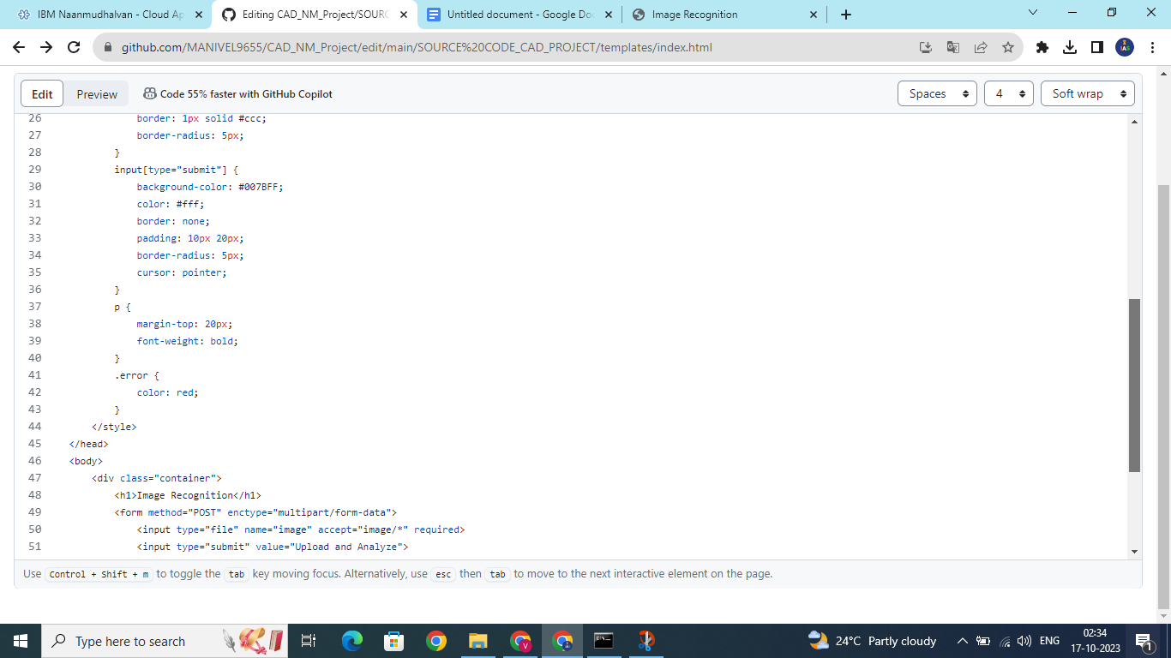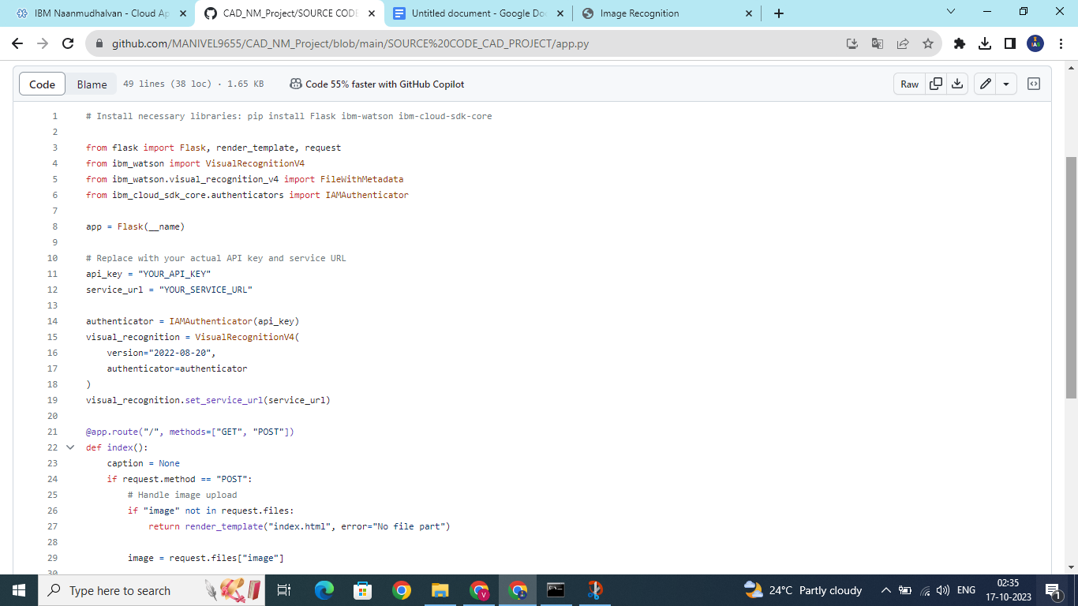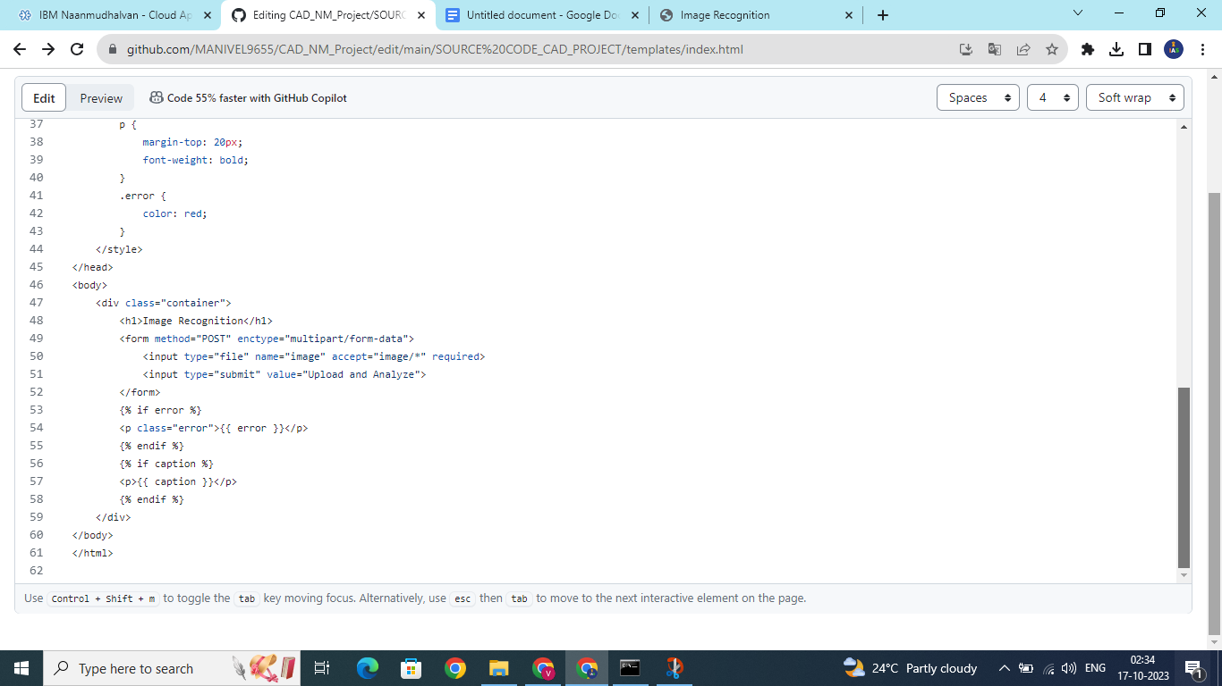

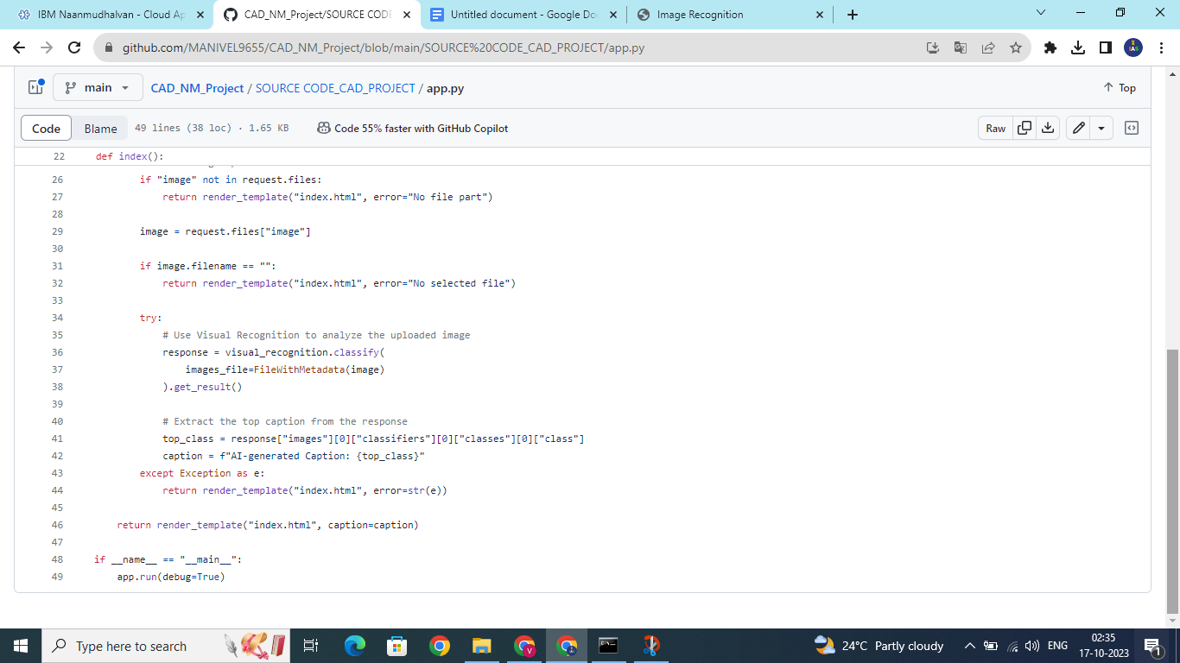

1. **Set Up IBM Cloud Visual Recognition**:

- Create an IBM Cloud account if you don't have one.

- Create a Visual Recognition service instance in the IBM Cloud.

- Get your API key and credentials for this service.

**2. Integrate IBM Visual Recognition :**

- Use the IBM Watson SDK or API to connect your application with the Visual Recognition service.

- Send images to the service for classification.

**3. Image Classification:**

- When a user uploads an image, send it to the IBM Visual Recognition service.

- Process the response to obtain classification results, which might include labels or tags describing the content of the image.

**4. Natural Language Generation:**

- Once you have the image classification results, use a natural language generation (NLG) system to create captions for the recognized images. OpenAI's GPT-3 or GPT-4 can be used for this purpose.

**Pythoncode:** 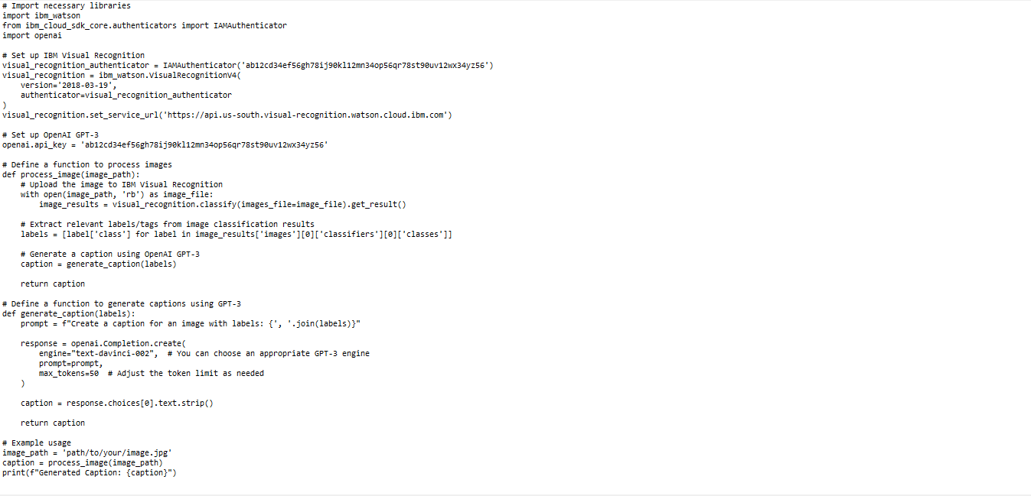

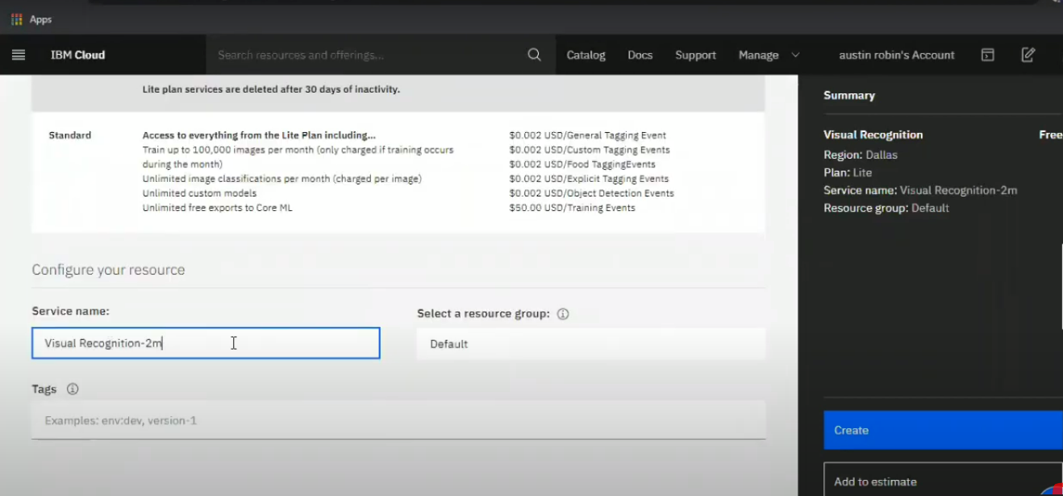

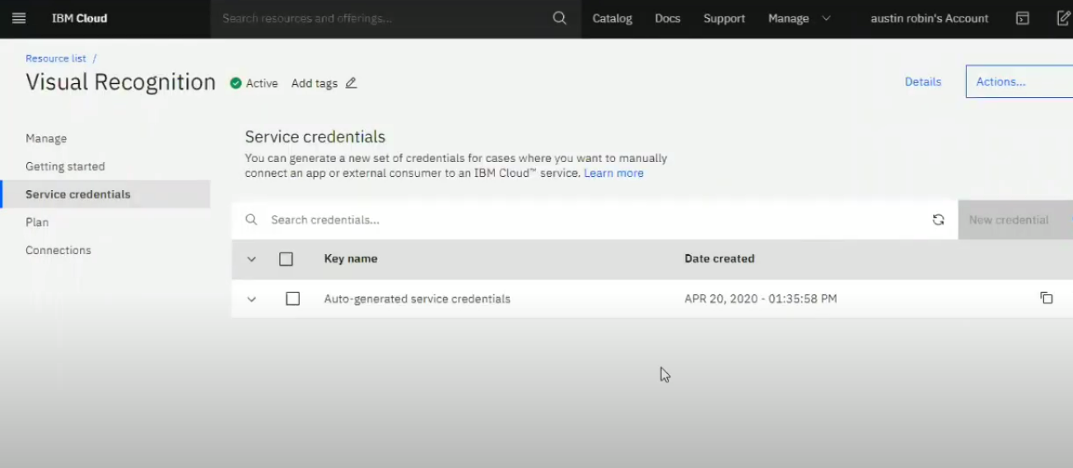

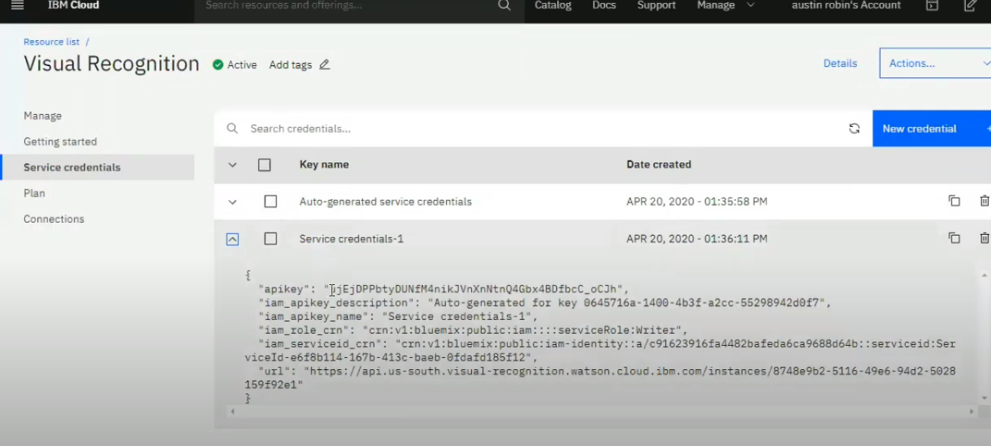

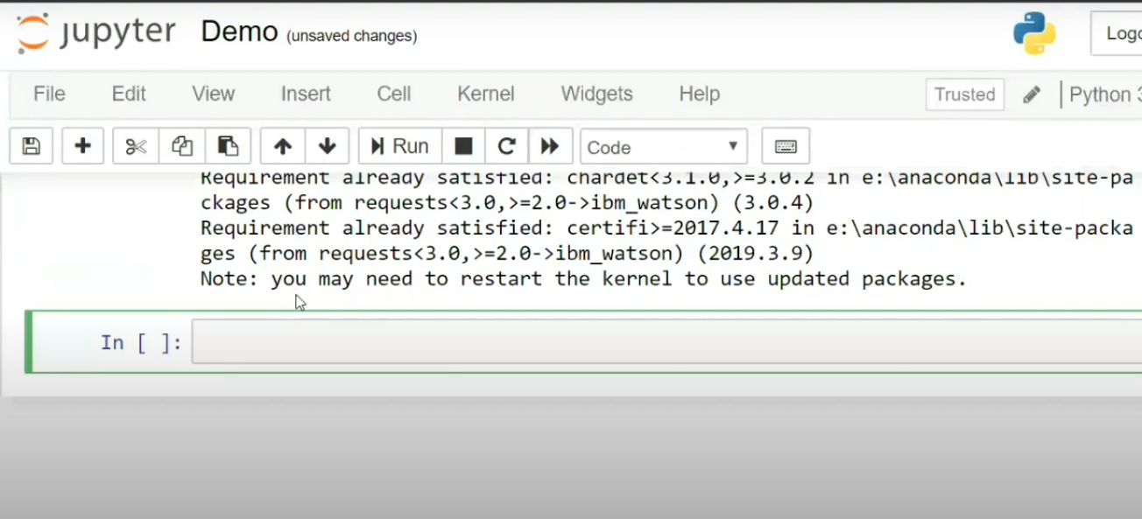

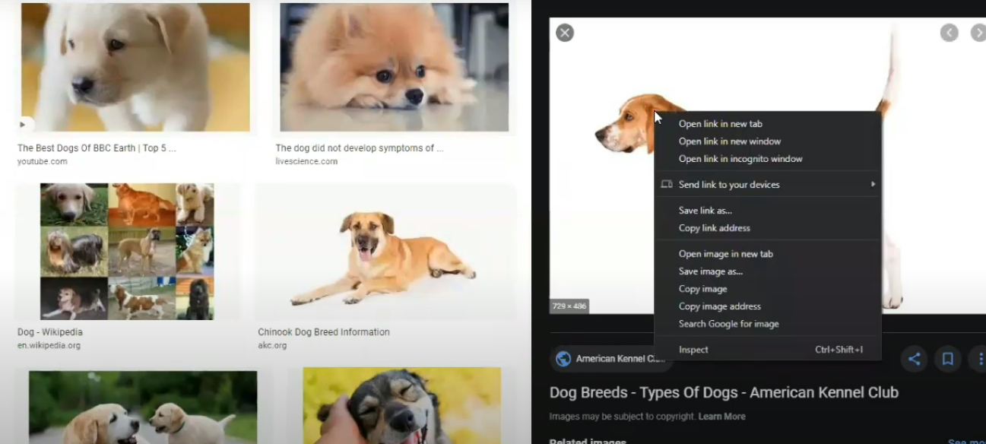

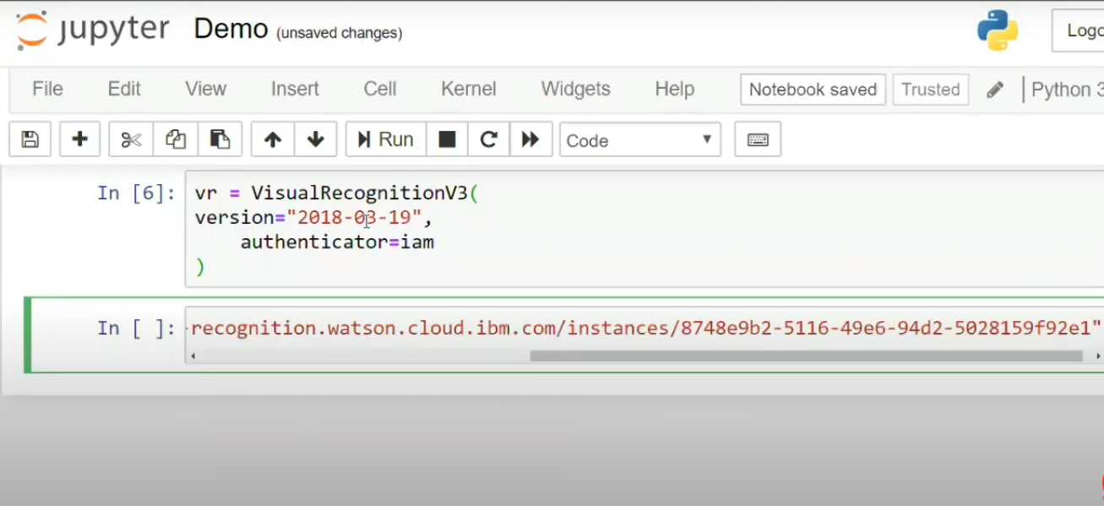

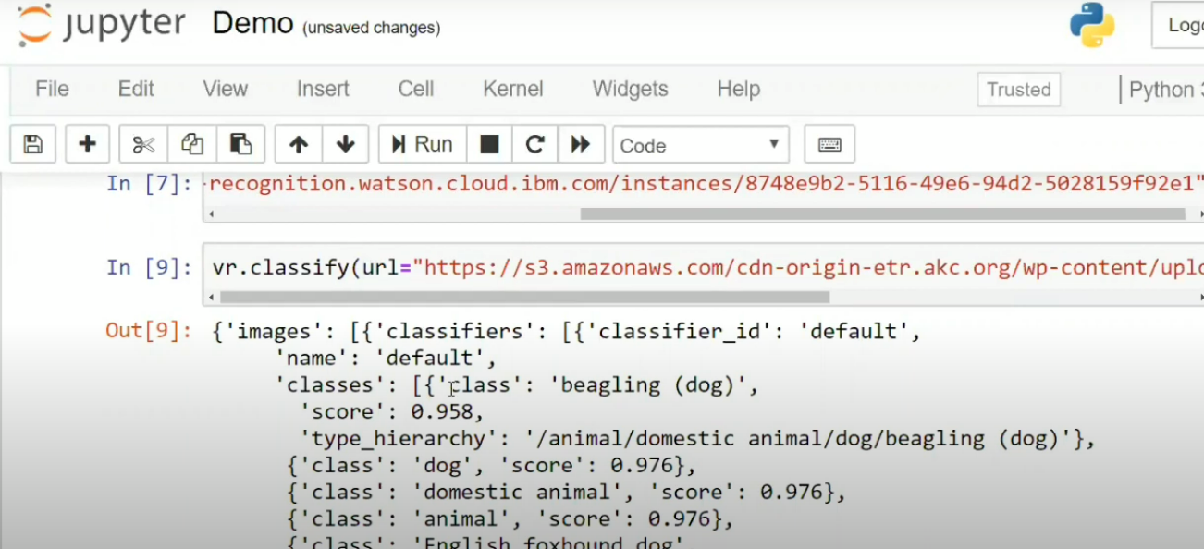

**PROPOSED SYSTEM:**

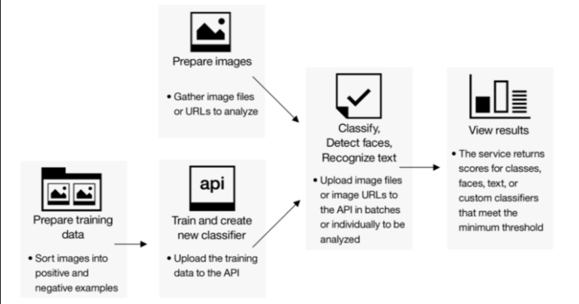

**SYSTEM REQUIREMENTS:**

**Software Requirements:**

**Operating System:** Windows 10

**Software :** IBM Watson Studio

**Hardware Requirements:**

**System Name:** Dell

**Processor:** Intel i5

**Conclusion**:

**Unlocking the Potential of Image Recognition with IBM Cloud Visual Recognition**

**1. Versatile Image Recognition:**

IBM Cloud Visual Recognition provides a versatile platform for recognizing and analyzing the content of images. Its pre-trained models are capable of identifying a wide range of objects and scenes, while custom models allow businesses to tailor the system to their specific needs.

2. **Automation and Efficiency:**

The integration of image recognition into applications and services brings automation and efficiency to a variety of industries. From inventory management in retail to enhancing security through facial recognition, this technology streamlines processes and enhances the user experience.

**3. Customization for Adaptability:**

The ability to create custom models stands out as a powerful feature of IBM Cloud Visual Recognition. This customization empowers businesses to adapt and innovate, allowing them to recognize objects or patterns specific to their industry, ultimately giving them a competitive edge.

**4.Transformative Tool:**

The project's exploration of use cases in healthcare, social media, and content moderation illustrates the transformative potential of image recognition. The ability to automatically tag and categorize images or analyze medical images opens new horizons in these fields.

1. **Future Opportunities:**

As visual data continues to grow exponentially, the demand for automated image analysis remains on the rise. IBM Cloud Visual Recognition, as demonstrated in this project, offers a pathway to seize these emerging opportunities.

In a rapidly evolving digital landscape, where visual content is ubiquitous, the project concludes that cloud-based image recognition services like IBM's offer not only practical solutions but also the capacity to unlock new frontiers of innovation. By embracing image recognition, businesses and developers can stay at the forefront of technological advancements and provide enhanced user experiences, all while automating and optimizing their operations. The potential of image recognition is vast, and with IBM Cloud Visual Recognition, it is within reach.

This project has provided a glimpse into the transformative power of image recognition technology, and it is a testament to the exciting possibilities that lie ahead as we continue to explore, adapt, and innovate in the realm of visual data analysis.